Setting Environment for Node and creating new project:

Step1: Install node.js from the given link <https://nodejs.org/en>

Step 2: Type ‘cmd’ in search bar to open command prompt and run commands to check version.

>node -v

>npm -v

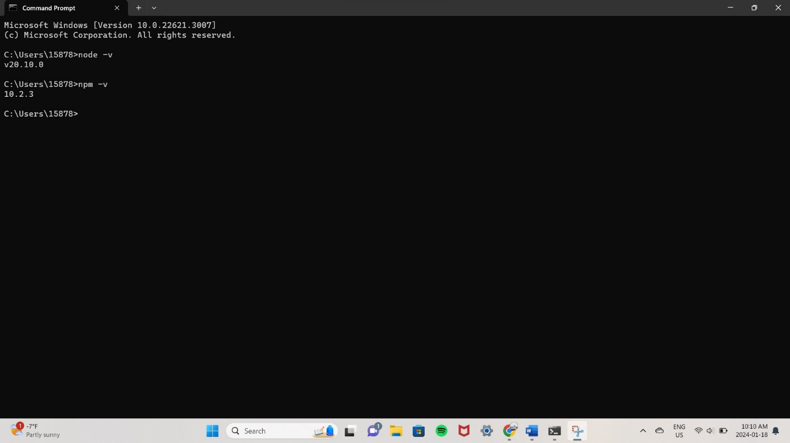

Step 3: After installing everything, create a folder “CPRG 303” in your C drive.

Step 4: Now , in cmd direct to the folder you created using cd command and paste the folder path.

>cd C:\CPRG 303

2

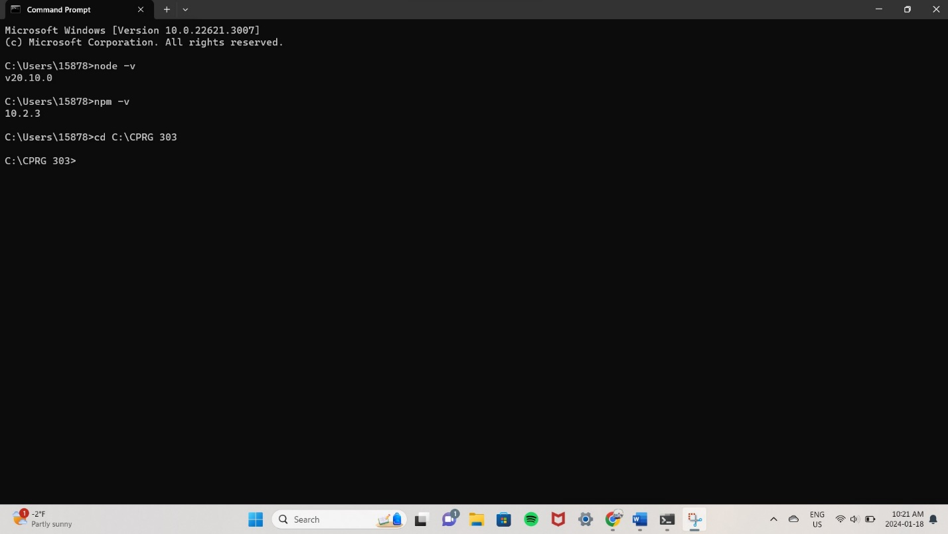

Step 5: Run command “npx create-expo-app” @projectname to create an application in desired folder.

>npx create-expo-app IncredibleToDo

Step 6: After installation and creation of app in your folder, run “npm start” command in cmd.

Step 7: We can run npm start command to get barcode.

>C:\CPRG 303\IncredibleToDo npm start

